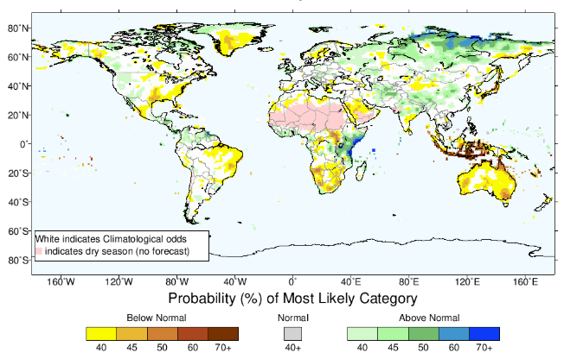

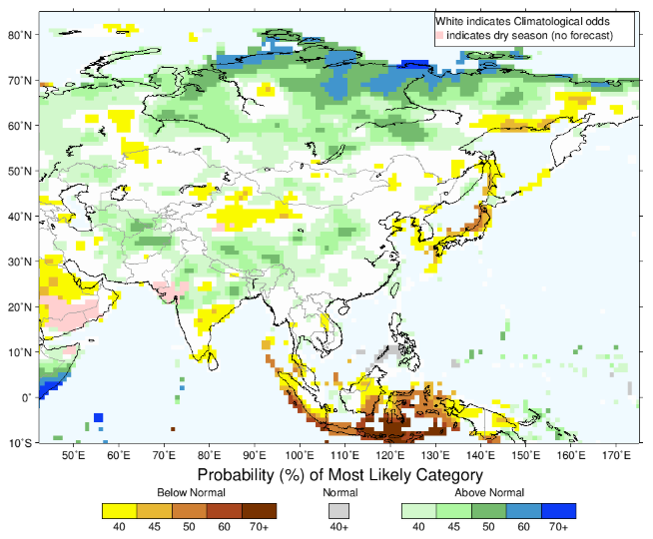

Modelu previsaun probabilidade ba presipitasaun udan been ba fulan Novembru, Decemberu, Janeiru 2020 tuir Instituto Pesquica Nasional ba Klima no Sosiedade hatudu katak previsaun presipitasaun udan been 60%-70% la to’o normal husi fulan Novembru to’o fulan Janeiru 2020 kobre Australia, Asia (inklui Timor-Leste), Africa, Norte America, America Sul no Europeia Oriental/nordeste. Detailus bele hare iha liña tuir mai:

<https://iri.columbia.edu/our-expertise/climate/forecasts/seasonal-climate-forecasts/>

husi parte seluk, ENSO relata katak previsaun klima neutral durante fulan ikus tinan 2019 to’o kuarter dahuluk tinan 2020. ENSO neutral, signifika katak iha efeitu uitoan deit ba klima iha Australia no global no la dezenvolve El=Niño ka La- Nina iha fulan hirak tuir mai. Status ne’e sei aktualiza karik aiha avaliasaun indika mudansa ba ENSO (El Niño or La Niña). Detailus konaba ENSO bele asesu iha lina tuir mai. <http://www.bom.gov.au/climate/enso/outlook/>

Ho fontes informasaun previsaun ne’e bele fo aviso antesipada no referensia durante epoka dahuluk tinan ne’e nian

October 2019 Climate Forecast Discussion for Nov-Jan through Feb-Apr

The [SST forecast](http://www.cpc.ncep.noaa.gov/products/NMME/seasanom.shtml) shows very slightly warmish, but neutral ENSO conditions (-0.5 to 0.5ºC in the Nino3.4 SST index) for Nov-Jan through Feb-Apr. Near-average or very slightly below-average SST is forecast for the eastern tropical Pacific, while above-average SST is forecast for the west-central and western tropical Pacific for all four forecast seasons. Most of the extratropical North Atlantic and North Pacific SSTs, as well as the SSTs in the western Indian Ocean and parts of the middle and/or high latitude south Pacific, are predicted to be above-average during the four forecast seasons. Areas having below-average SST are limited to the southeastern tropical and subtropical Pacific and the North Atlantic just south of Greenland for all four forecast seasons, for just south of Indonesia for Nov-Jan, and for just southeast of South America and just southeast of Africa for Nov-Jan and Dec-Feb. A positive Indian Ocean Dipole is predicted for all four forecast seasons, most strongly for the earlier seasons. Slightly above average SST is predicted for the north and south tropical Atlantic for all four forecast seasons, most strongly for the eastern portion in Nov-Jan.

An enhanced probability for below-normal precipitation is forecast in parts of southern Africa for Nov-Jan through Jan-Mar, parts of Greenland and part/most of Indonesia in Nov-Jan and Dec-Feb, and in parts of Australia in Nov-Jan. A tilt of the odds toward below-normal is also forecast for part of far eastern South America in Nov-Jan and Feb-Apr, and northwest Mexico/southwest U.S. in Jan-Mar and Feb-Apr. Enhanced chances for above-normal precipitation are forecast for all four forecast seasons for part of far northern North America, for eastern equatorial Africa and parts of northern South America in Nov-Jan through Jan-Mar, and for part of northern or northeastern Asia in Nov-Jan and Dec-Feb.

Enhanced probabilities for above-normal temperature are predicted for Greenland, and varying parts of Australia, Asia, Africa, North America, South America and eastern/northeastern Europe from Nov-Jan through Feb-Apr. Tilts of the odds toward above-normal are strongest for Nov-Jan in Greenland, northeastern Asia, and northern/northeastern North America. The tendency toward above-normal is weak or absent in central Africa, a significant part of Europe, most of Indonesia and the southern half of India during all four seasons. for east-central Asia from Oct-Dec to Dec-Feb and for small pockets in central North America for Dec-Feb. An enhanced probability for below-normal temperature is predicted in parts of central Asia and small parts of eastern or central North America in all four forecast seasons, and for a small part of India in Nov-Jan and Dec-Feb. Odds are also tilted toward below normal in eastern Europe in Dec-Feb and Jan-Mar, and for western Asia in Jan-Mar and Feb-Apr. Enhanced probabilities for near-normal temperature are forecast in all four forecast seasons for parts of northern South America, part of central and western Africa and parts of Indonesia. Near-normal is also favored in part of eastern equatorial Africa for Jan-Mar and Feb-Apr.